The world needs to move toward a sustainable future. We are going to see how Electric cars has affected the CO2 emission

Nuwan Hewabethmage

One of the major problems we are currently facing is the clime change. CO2 play a major role in climate change. Most of the world are trying to combat the CO2 emissions. We knew about climate change in the early 19 centuries. However, we are still depending on coal, petroleum, and other natural gasses.

We have renewable energy that could replace dependability Fossil fuel and coal. In this analysis we will se how fast the CO2 level in decreasing and How is renewable playing the part to decrease the CO2 levels.

1 data description and prep

We are using The United States Energy Information Administration or EIA has collected data on Carbon Dioxide Emissions from Energy Consumption from since 1973 January to June 2020. We are also using U.S department of energy PEV car sales by model. U.S department of energy PEV car sales by model gives us the United States sales for EV vehicles from 2010 to 2019. When we start looking at the EIA CO2 emission report, we can clearly see that One of the major contributors to CO2 emission is fossil fuel.

We already know the main causes of climate change is CO2 emissions. Furthermore, they also contribute to respiratory disease and air pollution. However, for the last few years there have been demand for renewable energy and electric cars.

We are interested in the relationship between CO2 levels and Electric cars. We want to see if the CO2 level started to decrease when the Electric car usage increases. There have been electric car companies that have stepped up to take the challenge to fight against CO2 levels. The data set we gathered from the U.S department of energy PEV car sales by model shows what cars are being sold and how many cars are being sold each year. There are few NA values in the data that I wanted to keep because it shows the demand for electric cars are increasing at a rapid rate.

Analysis

Figure 1:

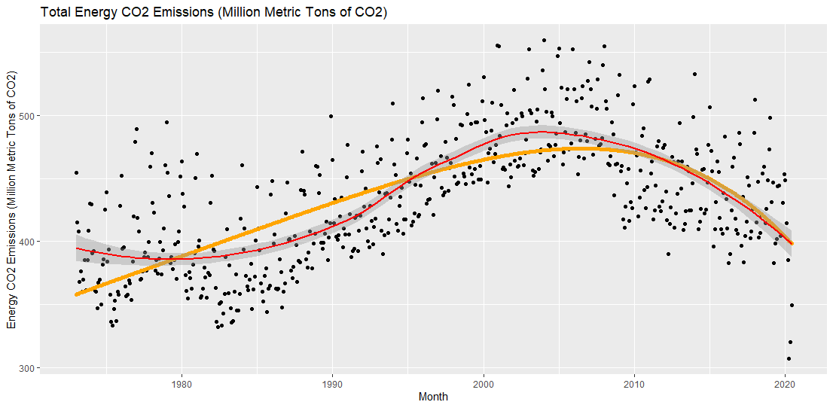

Above scatter plot diagram is the total CO2 emission in Million Metric Ton in the last 50 years. First, we can see in 2020 April and May the Total emission go down. Just to clarify that it does not mean we cut down on energy. The total CO2 emission is down is because Coronavirus. The yellow dots show that the CO2 level prediction and It also show that it is decreasing.

Figure 2:

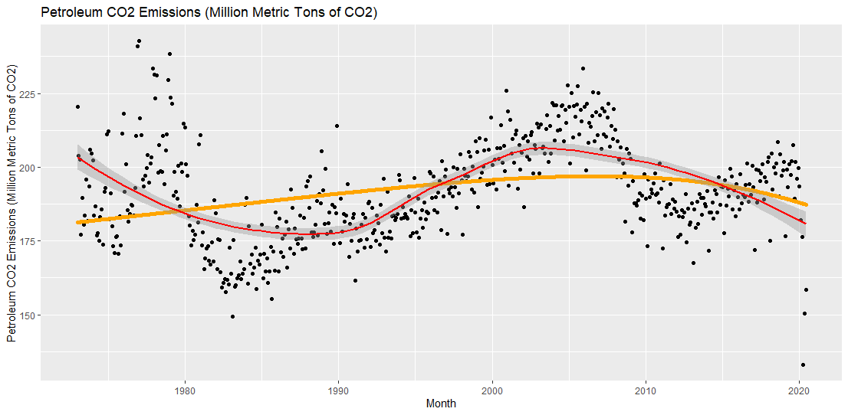

We know that the combustion engine cars are the main contributor for CO2 emission. In the first graph we can clearly see that the CO2 levels are decreasing. However, we can see in the second graph that CO2 level of Petroleum increased by little in the last five years. The demand for travel is increasing and the demand for electric vehicles are not going fast enough.

Figure 3:

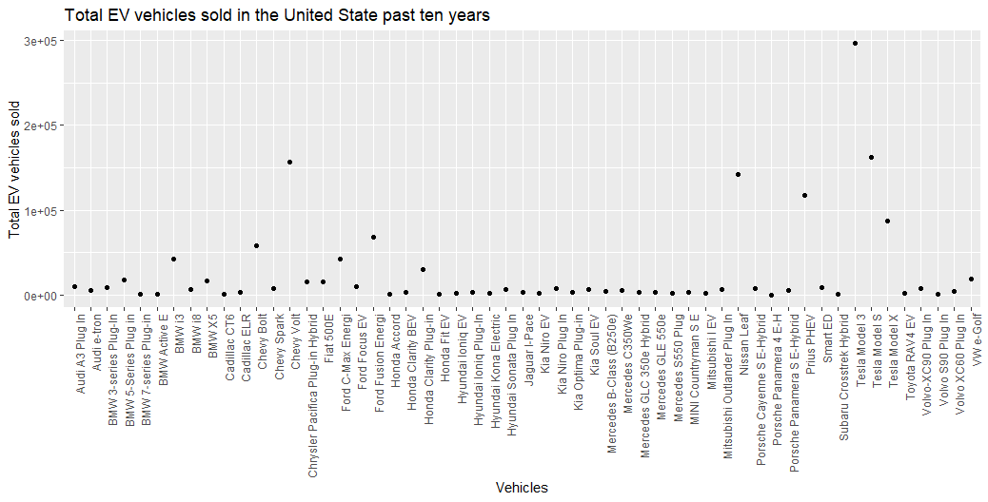

Above graph shows how many electric cars are sold in the past ten years. From the figure 2 we figured out that one of the major causes of Carbon Dioxide emissions are gas powered vehicles. One of the major ways that we are combatting emission of gas-powered cars is by using electric cars or EV vehicles. Electric cars do not produce any Carbon Dioxide. As a result, it is one of the best solutions to our problem.

Figure 4:

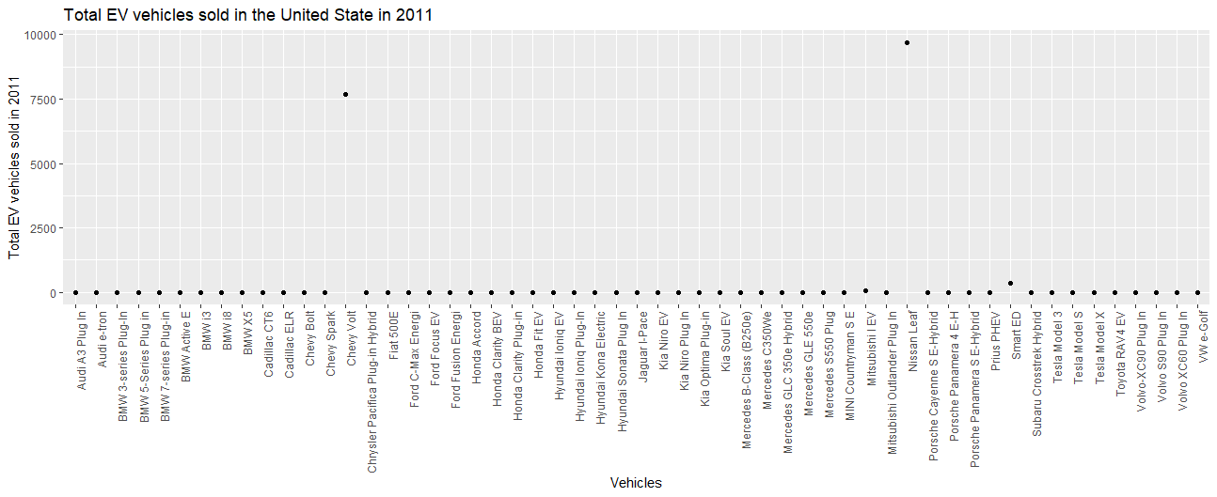

Figure 4, graph shows us 2011 electric car sales. Most of the cars did not exist at that time I still included them just to show the difference in 2011 and 2019

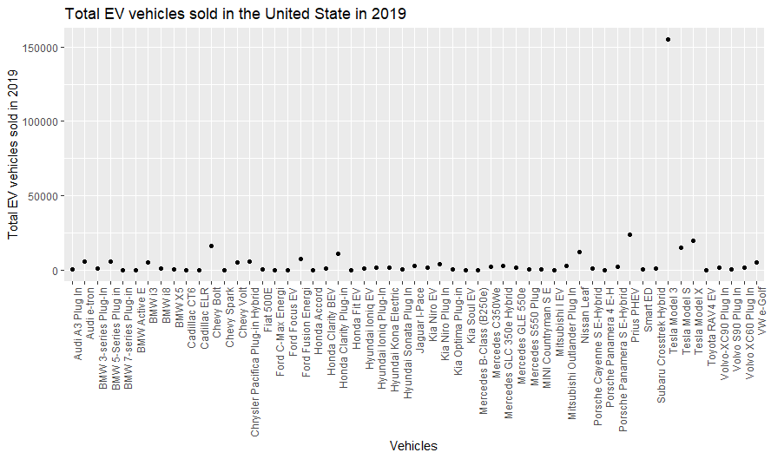

Above graph show the 2019 Electric car sales. In 2019 There were 326,644 electric cars sold. In 2011, there were only 17,763 electric cars sold. The difference in only 9 years is amazing.

As the CO2 levels start decrease, we can clearly say that the production of Electric car or EV cars has a clear effect. However, this brings other issues to the table. In 1996 the first ever electric car was produced by General Motors which was called EV1. In 2000, General Motors recalled the car and destroyed it. We would have better Chance of fighting the Carbon Dioxide emissions if that cars never recalled.

Carbon Dioxide emissions is becoming one of the biggest issues in the world we should find more solutions and try our best to move for a more sustainable future.